Shoebacca Carrier/Warehouse Selection

# Warehouse Configuration

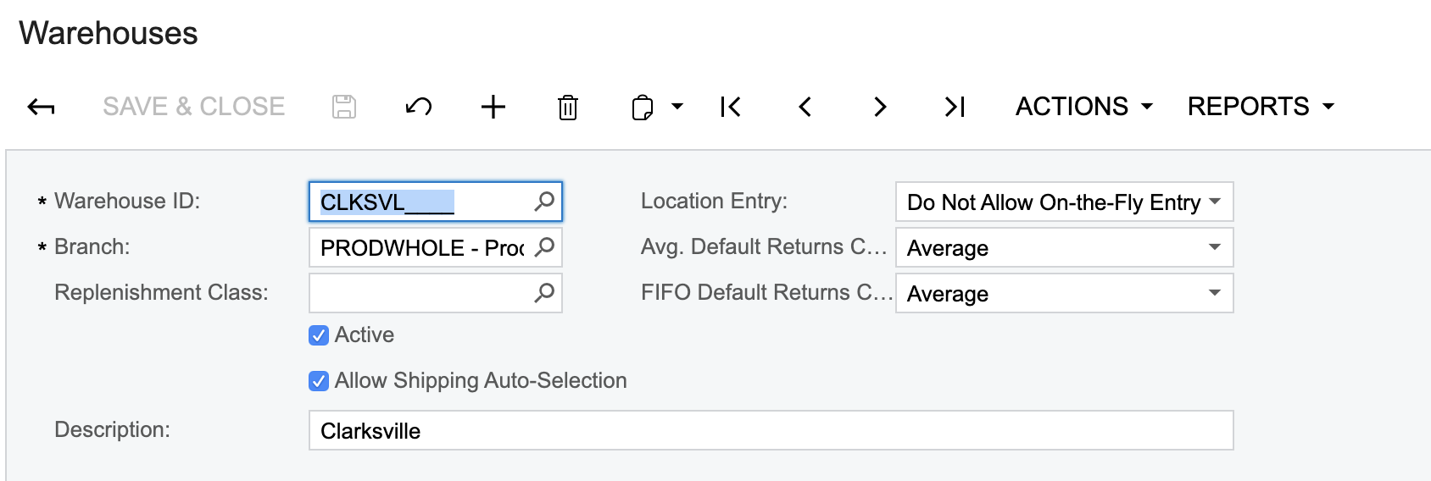

* Allow Shipping Auto-Selection When checked, this warehouse will be considered and availability for the items contained on the order will be checked during the shipment creation process

# Carrier Configuration

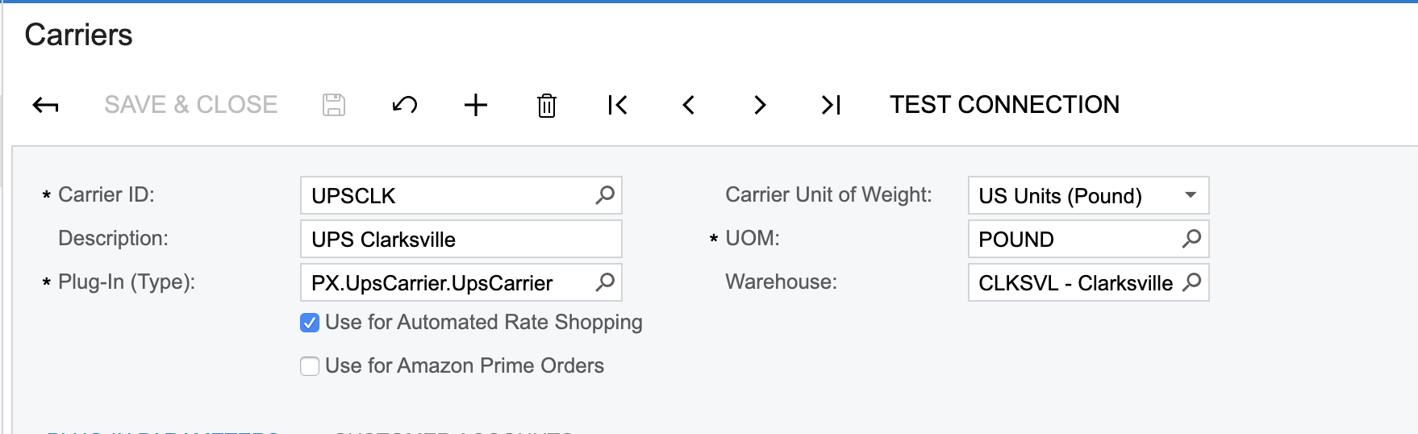

* Use for Automated Rate Shopping: when checked, the system will check available rates for this carrier during shipment creation and confirmation to determine best available rate.
* Use for Amazon Prime Orders: determines if the carrier can be used for orders marked ‘Is Prime Order’ (SOOrder.UsrISPrime) during the shipment confirmation process. Note that this flag is not evaluated during shipment creation.
* Warehouse: Carriers that are specific to a warehouse (UPSCLK, UPSIRV should be linked to the warehouse)

# Work Calendar Configuration

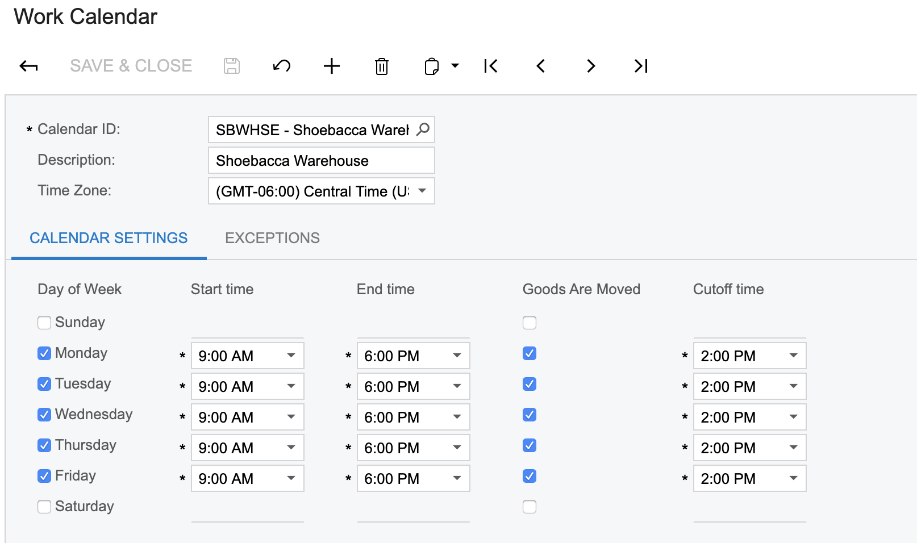

A work calendar with the ID ‘SBWHSE’ is required. Orders received after the Cutoff time configured will be shipped during the next day where goods are moved. Exceptions can be configured for holidays.

# Order Creation

The following fields are used during the shipment creation and confirmation processes:

* Placed Date (SOOrder.UsrOrderPlacedTimeStamp): the date/time the order was originally placed. The scheduled shipment (SOOrder.ShipDate) will be automatically calculated based on this date and the SBWHSE calendar.
* Sched. Shipment (SOOrder.ShipDate): calculated automatically based on the Placed Date.
* Deliver By: date the order needs to be delivered to customer. This field is set by the connector. The Deliver By date is only considered during rate shopping and shipment confirment if Guaranteed is checked
* Guaranteed: indicates that the Delivery By date is a guaranteed delivery date. Only shipping methods with a guaranteed delivery date equal or less than the Deliver By date will be considered.
* Preferred Warehouse ID: leave blank if you want the system to automatically determine where to ship the order from. If you set a preferred warehouse ID, the warehouse selection logic will not be executed; use for NAFTA orders or to bypass the warehouse selection logic for a problematic order.
* Ship Via: the preferred ship method for the order. Leave blank or use one of the following methods if you want the system to select the ship via automatically during shipment confirmation: FREESHIP, GROUND, OVERNIGHT, 2DAY. Note: the actual Ship Via is not important; the Deliver By data is what is used to determine the least expensive method.

Packages

* An automated packaging algorithm is used during shipment creation. If you set packages manually, the rate shopping algorithm will not run and the system will use the first warehouse in the list of possible warehouses.

# Shipment Creation

* If a preferred warehouse is set, the standard Acumatica shipment process is executed.
* If no preferred warehouse is set, we start by checking availability in all the warehouses that have “Allow Shipping Auto-Selection” checked.
* If a single warehouse can fulfill the entire order, this warehouse will be assigned to every item. If more than one warehouse can fulfill the entire order, a rate shopping is done to identify the warehouse where it will be the least expensive to ship from.
  + Only carriers that have “Use for Automated Rate Shopping” checked and that are linked to the warehouse we are calculating will be evaluated.
  + Packages are estimated based on the total quantity of items in the order and relies on the following (hardcoded) packages: 01 PACK, 02 PACK, 03 PACK, 04 PACK, 06 PACK, 10 PACK. If more than 10 units are present on the order, additional packages will be included; the declared value and weight is pro-rated in this case. If you set packages manually, the rate shopping algorithm will not run and the system will use the first warehouse in the list of possible warehouses.
  + For orders with guaranteed delivery, ship methods that do not meet the Deliver By date are ignored when determining the least expensive carrier and warehouse.
  + If the same rate is found for more than one warehouse, the system will ‘roll the dice’ and randomly decide if it should use the current lowest warehouse or the new one that has the same cost. The goal is to balance the load for these cases, however it could make sense in the future to skew/prioritize warehouses based on available personnel and other logistical considerations.
* Please note the following limitations in the current algorithm
  + A single line with a quantity >1 will not be split automatically if it can’t be fulfilled from a single order; you have to manually set a preferred warehouse on the order and on the line in these cases.
  + The algorithm that assigns the warehouse on a per-line basis when the order can’t be shipped in full does not try to minimize the number of shipments made. This is not a problem with two warehouses, but if additional warehouses eventually get added then it will make sense to improve this algorithm to minimize the number of shipments made and optimize costs.

# Shipment Confirmation

* A rate shopping is done during shipment confirmation to identify the least expensive carrier/ship via that allows us to meet the ‘Deliver By’ date. The rate shopping is done when the Ship Via field is blank or is set to one of the following methods: FREESHIP, GROUND, OVERNIGHT, 2DAY
* Only carriers that have “Use for Automated Rate Shopping” checked and that are linked to the shipment warehouse will be evaluated.
* Amazon Prime orders (SOOrder.UsrIsPrime) are always restricted to carriers that have “Use for Amazon Prime Orders” checked. Non-Prime orders are restricted to carriers that have “Use for Amazon Prime orders” unchecked. If the shipment is linked to multiple orders, the shipment will be considered a Prime shipment as soon as at least one order is an Amazon Prime order.
* Packages need to be set before the order is confirmed; the custom packaging algorithm is not used during shipment confirmation.
* For orders with a guaranteed delivery date, ship methods that do not meet the Deliver By date set on the original order will be ignored when determining the least expensive carrier and ship method. If Guaranteed is not checked, every ship methods will be considered including those without a guaranteed delivery date. If the shipment is linked to multiple sales orders, the earliest Delivery By date is used.
* If there’s more than one carrier/ship method that meets the Deliver By date at the cheapest available price, the first one is used; there is no logic to favor a given carrier/ship via over another.